Density Edge is line between two core points with distance <= Eps.

That means a Density edge always have length less than Eps.

So in below image P and Q are core points and dist. Between P and Q <= Eps so the line connecting them is called Density Edge.

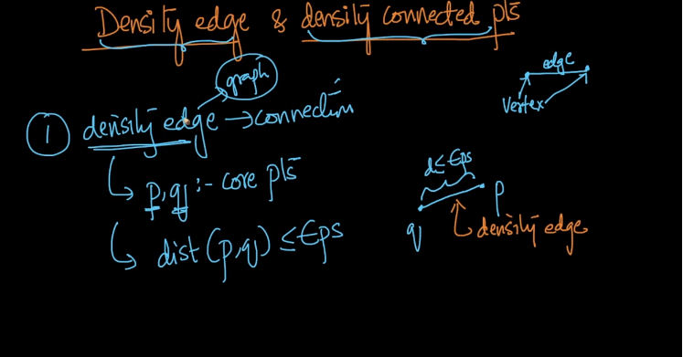

Now Density Connected points are nothing but if there exists a path between two points where we can move from one points to other using density edges only.

So in below image P and Q can be travelled using density edges only and P and Q are density connected points.

Note here p1, p2, p3 are also core points.

